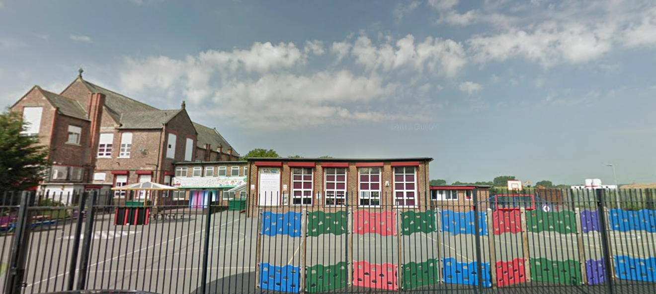

‘Keeping Christ at the heart of all we do’

**St. Sebastian’s R.C. Primary School**

**Curriculum Overview**

**Year 6 Autumn**



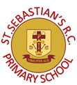

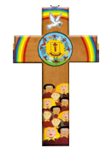

|  |  |
| --- | --- |
| **Class Information**  Reading – regular reading at home is essential to build up your child’s vocabulary and pace. Please try to read for at least twenty minutes each evening and sign your child’s reading record daily.  Times tables – the rapid recall of multiplication facts is vital for accessing the mathematic curriculum. Regular practise at home is invaluable to prepare your child for lessons in school. Children should access TTRS from home daily.  Spellings – our in-class spelling practise can be supported at home using a weekly spelling quiz on Purple Mash.  P.E – our P.E days are Tuesday and Wednesday. Children need to arrive at school wearing their PE kit and suitable footwear. | |
| **English** | **Narrative:**  In our narrative writing, we will study the book, ‘A Monster Calls’ and use it to produce a piece of narrative writing.  **Non-Fiction:** Using the book ‘Letters From The Lighthouse’ we will write an interview-style recount of events. |
| **Maths** | As mathematicians, we will focus on place value up to 10,000,000. We will compare and order numbers and practise rounding numbers. We will then explore addition, subtraction, multiplication, and division, including solving multi-step problems in real-life contexts. We will move on to explore common factors, multiples and square/cubed numbers. The children will revise how to compare and order fractions, then move on to use the four operations to solve fraction calculations. |
| **Religion** | This term we will focus on the topics:  Loving: A God who never stops loving us  Vocation & commitment: The vocation of priesthood and religious life  Expectations: Jesus born to show God to the world  World Religion: Judaism  As Christians, we will begin the year by looking at the different ways in which we can show love to all people. Our theme of ‘Loving’ will explore God’s unconditional love for everyone and how we can learn from His teachings to spread that love in our world. Using different passages from the Bible we will explore the ways in which God’s love is represented in scripture and what messages we can take from parables to influence our daily lives. |
| **Science** | The children will enjoy an Electricity Day in Autumn 1 where they will learn to associate the brightness of a bulb/volume of a buzzer with the number and voltage of cells used in a circuit. They will compare and give reasons for the variations in how components function and use recognised symbols when representing a simple circuit in a diagram. The children will then move on to identify the kingdoms of life and how to classify living things within those kingdoms. |
| **Geography** | The children will learn about the different countries in the United Kingdom by comparing their landscape and physical characteristics. We will familiarise ourselves with major cities across the UK, their locations and the people who live there. Our final focus will be industry in the UK and involve learning about the different sources of energy that help to power our home. |
| **History** | As historians, we will investigate the women’s suffrage movement of the early 20th Century and its links to Manchester. We will explore the life of women during this time and learn why the suffrage movement was a key part of women’s fight for equal rights. We will learn about the life of Emmeline Pankhurst and her role during this period of history, making links to her life in Manchester and the importance of our local area in the fight for the rights of women. |
| **Design & Technology** | As designers, we will be exploring how mechanisms work and will begin to use mechanical systems such as levers, wheels, cams, gears and pulleys in products that we will be designing ourselves. |
| **Art** | As artists, we will be looking at the work of Lowry and his interest in the lives of those who were working class. We will focus on the form of his work, particularly his “matchstick” characters. We will also research his use of colour within his paintings to identify how he incorporates social issues at the time. |
| **Computing** | We will focus on internet safety and how to stay safe when playing online games, including the use of location settings. We will also be aiming to design and make a more complex program using coding. |
|  |  |
| **Music** | This term we will explore performing together in different parts. The children will, through a range of activities, practise rhythm, instrumentation and performance, resulting in a whole class performance involving instrumental and vocal performances.  In Autumn term we will be appraising pieces of music in different genres with a focus on pop, soul and jazz music. |
| **PSHE** | This term, we are focusing on RHE (relationships and health education), specifically looking at how the children are growing and changing and how this links to our emotions. We will also be looking at the British values of Democracy. |
| **PE** | This term, the children will learn the rules of basketball and apply this to a game. Moving on, we will learn and develop our dance skills. The children will be taught by a physical education specialist. |