**Geography**

**How does the formation and location of a mountain affect its climate?**

Sea

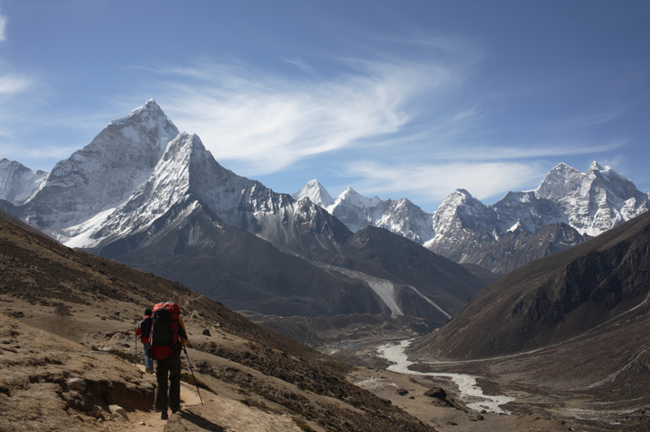

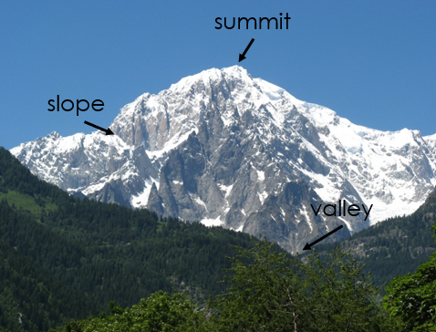

**Key Vocabulary**

**Climate –** the pattern of weather in a place over a long period of time.

**Mountain –** a landform that rises above the surface and is higher than the surrounding area.

**Seven Summits –** the highest mountains in each of the seven continents.

**Slope –** the side of a mountain.

**Summit –** the highest point of a mountain.

**Valley –** this is the dip between two mountains.

In Geography, we will develop our skills by studying different mountains across the globe. We will discover their different environments and characteristics. We will investigate some key questions:

* Where are the Seven Summits located?
* How are mountains formed?
* How can we describe the climate of a mountain?
* Where are the UK’s highest mountains and what are their environments like?
* What is the importance of the Himalayas for people living in the region?