Knowledge organiser – Mountains
What will we be learning?
- What a mountain is.
- The features of a mountain.
- How mountains are formed.
- Mountain climates.
- The UK and world’s highest mountains.
- The importance of the Himalayas.
Key facts
The World’s Seven Summits (the highest peaks on each continent):

Everest (Asia), Aconcagua (South America), Denali (North America), Kilimanjaro (Africa), Elbrus (Europe), Vinson Massif (Antarctica), Carstensz Pyramid (Oceania)
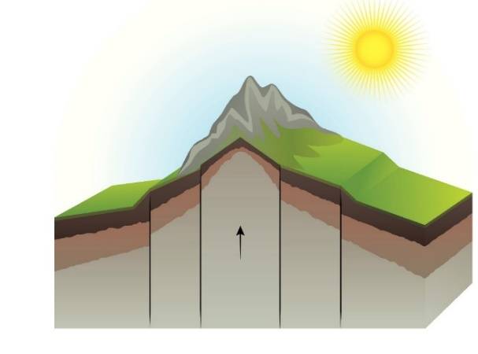
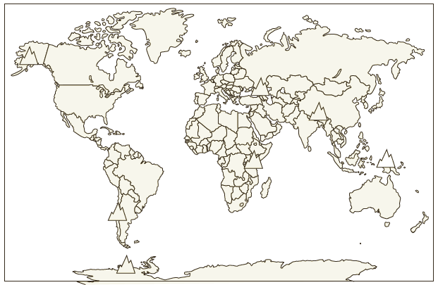
Key knowledge
A mountain is a landform that sticks up, high above the surrounding land. It is much taller than a hill (600 metres or above, in the UK) and is often found grouped with others in a mountain range.
Mountains are formed when two of the earth’s plates collide and land is pushed upwards or folded.
Mountains have their own climates.

Place names | Geographical terms and processes | Locational terms
Ben Nevis  Himalayas  Mount Snowdon  Pacific Ring of Fire  Scafell Pike  Slieve Donard | alpine  avalanche  landform  slope  summit  valley | altitude  height above sea level  map index  map reference  scale bar
Glossary
dome mountains: mountains formed by magma pushing upwards, but without a volcanic eruption
fault-block mountains: mountains formed by parts of a broken plate being forced upwards
fire mountains: mountains formed by volcanic eruptions
fold mountains: mountains formed by the earth’s plates pushing together
scale bar: a line that shows how many kilometres there would be in the real world for every centimetre on a map.

