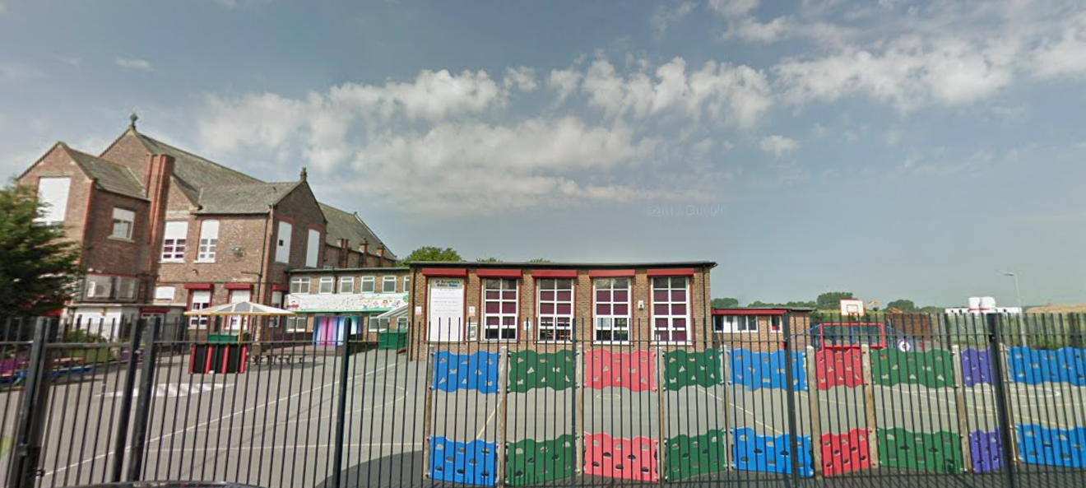

‘Keeping Christ at the heart of all we do’

**St. Sebastian’s R.C. Primary School**

**Curriculum Overview**

**Year 3 Autumn**



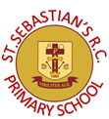

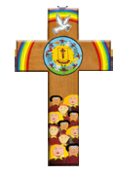

|  |  |
| --- | --- |
| **Class Information**  Spellings- spellings will be taught on Monday. The children will practise writing these each morning. They will be tested on Friday.They will have access to a spelling quiz each week on purple mash.  Homework-children will receive a piece of maths and grammar homework each week on Fridays to be returned on Wednesday.  Reading- regular reading at home is essential to build up your child’s vocabulary and pace. Please try to read for at least twenty minutes each evening and sign your child’s reading log.  Times tables- the rapid recall of multiplication facts is vital for accessing the mathematic curriculum. Regular practise at home is invaluable to prepare your child for lessons in school. These will be tested each Friday.  P.E- our P.E day is Tuesday and Friday, please make sure your child has the appropriate shorts, t-shirt and foot wear. | |
| **English** | **Narrative:**  The children will read and analyse Stone Age Boy. They will write their own stories based on the same theme. The children will reading the amazing book eating boy and modelling their own story about an unusual eater..  **Non-Fiction:** The children will read and analyse the structure and features of an explanation text called rocks beneath my feet. The children will write their own explanation text about volcanoes. |
| **Maths** | As mathematicians we will compare, order the numbers to 1000. We will add three digit numbers to one digit number and **s**ubtract a 2-digit number from a 3-digit number .Pupils will recap the two, five and ten times tables and relate to division. They will learn the three, four and eight times tables and their division facts. |
| **Religion** | For Christians the pattern and ideal of family life is found in the Scriptures. God is the loving parent of the human family and Jesus was born and lived in a human family. While offering ideals for family life. The children will also study baptism and the symbols included in the sacrament. Towards advent the children will consider the impact of visitors to our home and the role in the nativity. |
| **Science** | The unit takes learners on a journey- from describing how light travels to considering how light reflects off a surfaces and how shadows are formed. Different sources of light are also explored, from the sun to torches. Children get the opportunity to build their own torches and periscopes, as well as observe and measure the distance and angle that light travels. The children will also look at how certain types of rocks are formed and their properties. They will apply this to their uses. |
| **Geography** | We will investigate the big question: What are the characteristics of the climate zones? The children will investigate how the location of a country can affect its climate which impacts on the landscape . They will locate the different climate zones and compare the temperatures and rainfall of each. |
| **History** | As historians we will use a range of sources both primary and secondary to investigate the big question: What can we learn from the Stone Age? The children will consider the chronology of the period and what information can be inferred from Skara Brae. They will consider how homes, food and culture has influenced today’s society. |
| **Design & Technology** | This term we will be designing and making pulleys and levers. The children will investigate the use of pulley’s and levers in products. They will then design and make their own product. Finally they will evaluate their product. |
| **Art** | We have developed an art project to run alongside this history topic to enhance the children's learning, understanding and experience. We will begin by reading the first story in the book: 'Vincent's Starry Night and Other Stories', which is a wonderful book explaining the history of art from prehistoric to modern times. We will analyse the lion man, which was one of the first carvings. Children will have the opportunity to interpret cave drawings and create their own whilst experimenting with tone, shade and texture. |
| **Computing** | The children will be investigate online safety, thinking about the children’s commissioner digital 5 a day.They will also be introduced to tough typing to assist with future topics. |
| **Music** | As musicians, we will use our voices expressively and creatively by singing songs, chants and rhymes. Particularly focusing on the song- Let Your Spirit Fly The children will also use glockenspiels to play rhythms and learn the basics of reading music. |
| **PSHE** | The children will celebrate mental health week by considering how to keep their minds healthy. They will build up an bank of ideas of activities to keep their minds healthy. |
| **PE** | The children will be thinking about the skills and techniques of invasion games with a specialist sports coach. They will also be practising the leaps, roll and stretches during a gymnastics session. |