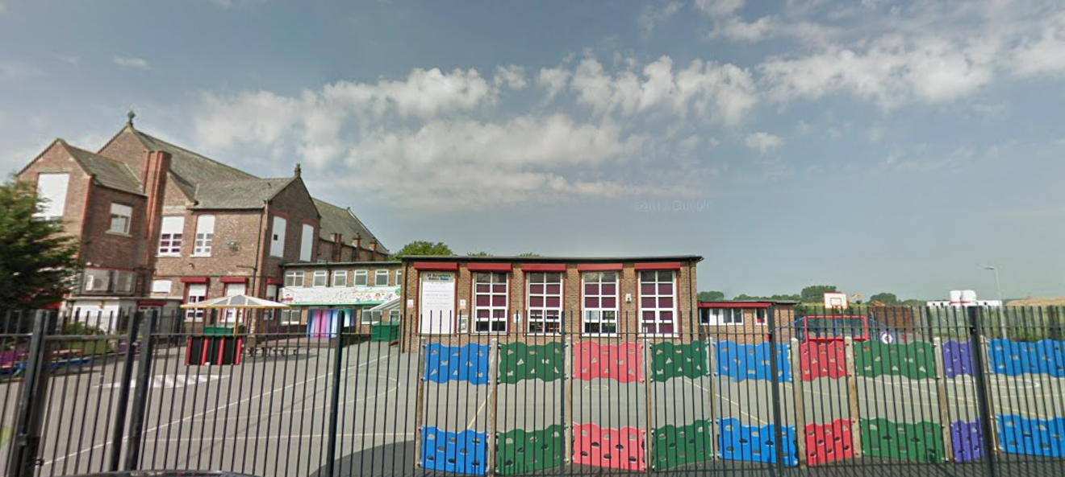

‘Keeping Christ at the heart of all we do’

**St. Sebastian’s R.C. Primary School**

**Curriculum Overview**

**Year 3 Summer**



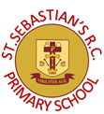

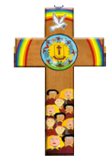

|  |  |
| --- | --- |
| **Class Information**  Spellings- spellings will be taught on Monday. The children will practise writing these each morning. They will be tested on Friday.  Homework-children will receive a pages in the homework booklets to consolidate the classroom lessons. This will be given on Fridays and returned on Wednesdays.  Reading- regular reading at home is essential to build up your child’s vocabulary and pace. Please try to read for at least twenty minutes each evening and sign your child’s reading log.  Times tables- the rapid recall of multiplication facts is vital for accessing the mathematic curriculum. Regular practise at home is invaluable to prepare your child for lessons in school. These will be tested each Friday.  P.E- our P.E days are Tuesday and Wednesday. Children can come to school in there PE kits these days. The kit is a white plain t-shirt and black shorts or jogging bottoms and pumps or trainers. | |
| **English** | **Narrative:**  We will be analysing the structure and language of myths by focusing on Theseus and the Minotaur, the children will write their own Greek myth  **Non-Fiction:**. We will focus on non-chronological reports by analysing the composition, features and language of a report on the human body. The children will transfer their skills to write a non-chronological report about plants. |
| **Maths** | We will revisit fractions initially during maths sessions. The children will continue to practice telling the time and problem solving relating to money and the coins to make a certain amount. They will investigate 2d and 2d shapes and their properties. We will end the year analysing statistics. |
| **Religion** | This term we will concentrate on Pentecost and the transfer of energy. We will consider why the disciples needed energy from the Holy Spirit and how this was received. We will analyse how the church celebrates Pentecost and how we can use this energy in our daily lives. |
| **Science** | As scientists we will investigate the conditions a plant needs to grow by nurturing our own plants. We will analyse the features a plant has to reproduce and how it does it. The children will investigate a flowering plants life cycle. |
| **Geography** | Using a range of maps and sources we will investigate South America and Rio. We will use topographical maps to identify its key features.We will use lines of latitude and longitude to locate South American countries. We will consider the similarities and differences between Brazil and our own country and what daily life in Rio de Janeiro is like. We will consider the importance of South East Brazil’s trade links. |
| **History** | As historians we will use a range of sources both primary and secondary to investigate the big question: How can we find out about the civilisation of Ancient Greece? We will consider how they were governed, the myths and the achievements of Alexander the Great. |
| **Design & Technology** | The children will designing and making their own pencil case according to a design brief. They will investigate the best type of stitching and ensuring it is fit for purpose. |
| **Art** | The children will study the designs of ancient Greek pottery and the meaning of the pictures, they will design and make their own pot. |
| **Computing** | The children will investigate simulations using purple mash. They will use a program that models a real-life situation. They will try things out that would be too difficult or dangerous to do in real life. |
| **Music** |  |
| **PSHE** |  |
| **PE** | This term the children will focus on athletics and cricket. |